OSSP-SKILL-WEEK11
SESSION-21
Task1: To Connect Modules, Validate Interfaces, Test End-to-End Execution, Handle Errors, Improve Reliability, Refactor Components
Source code:
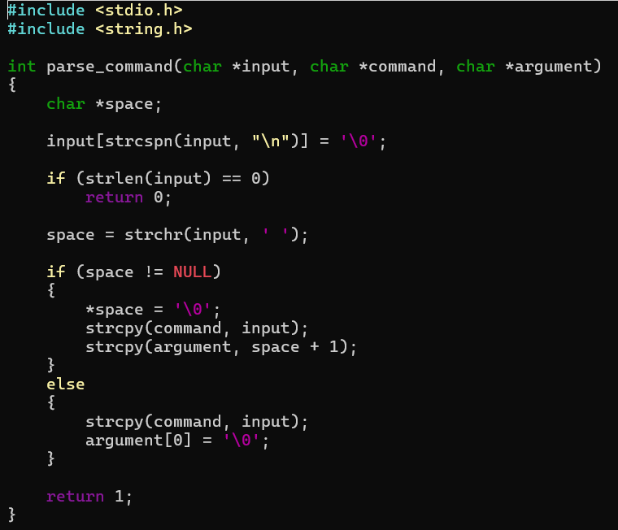
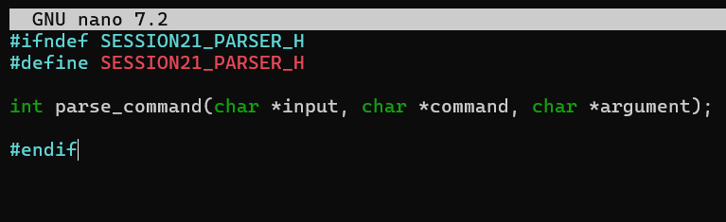
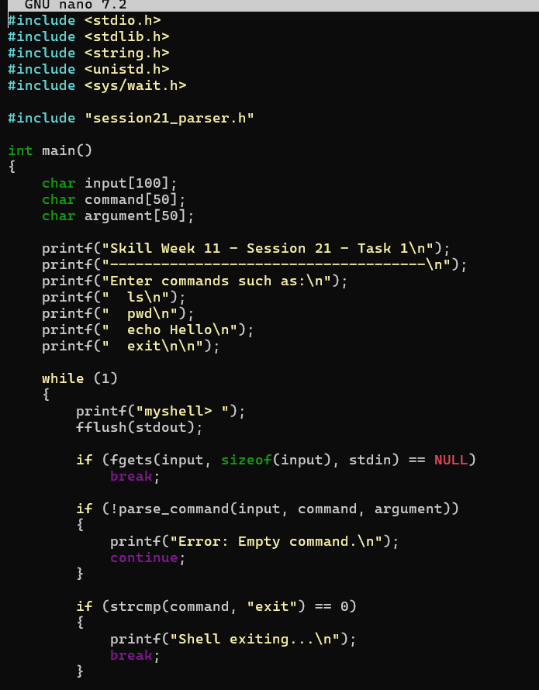
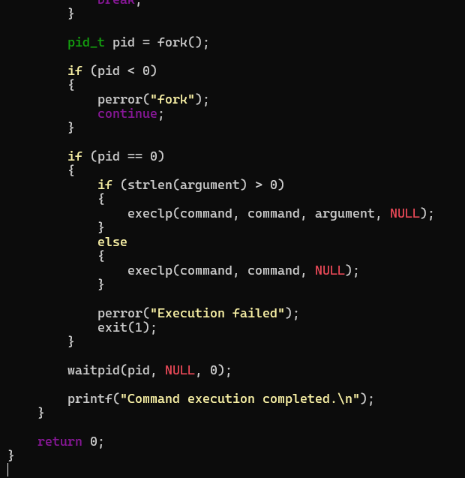
Output:
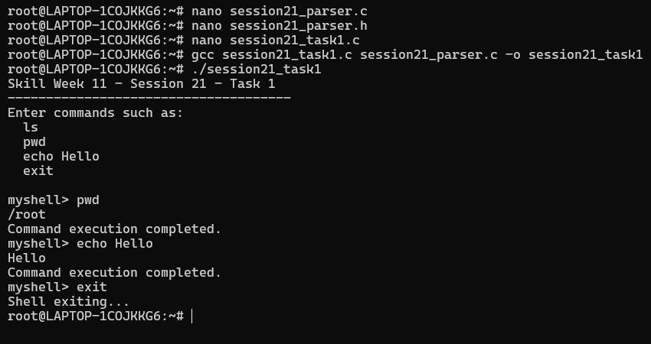
Observation: I learned how different modules can be connected through header files and function interfaces. I understood how parsing, process creation, command execution, and synchronization work together in an end-to-end shell.
Task2: Develop a shell program that detects runtime errors, generates meaningful error messages, logs failures, handles invalid commands/syntax, and recovers gracefully from error conditions.
Source code:
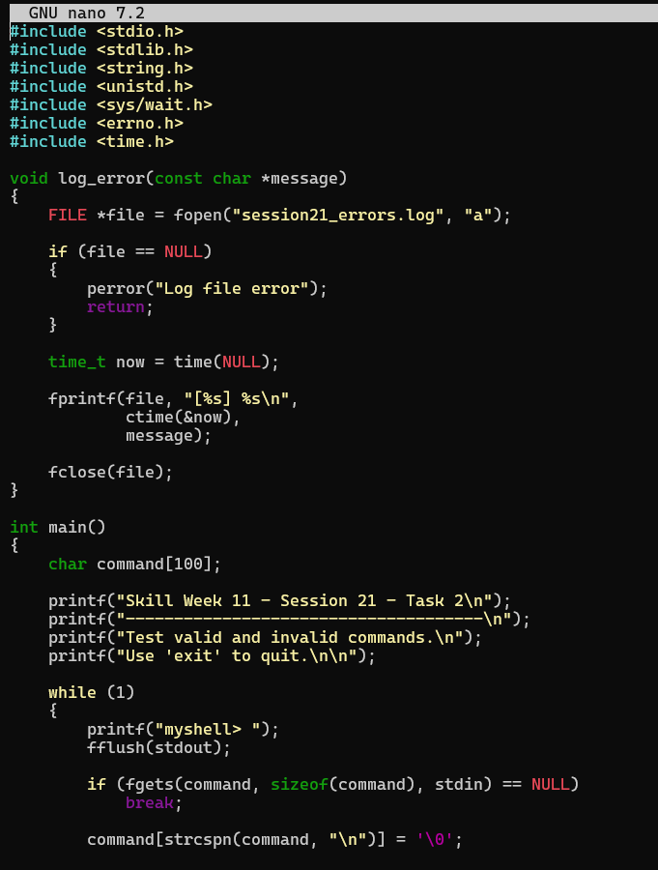
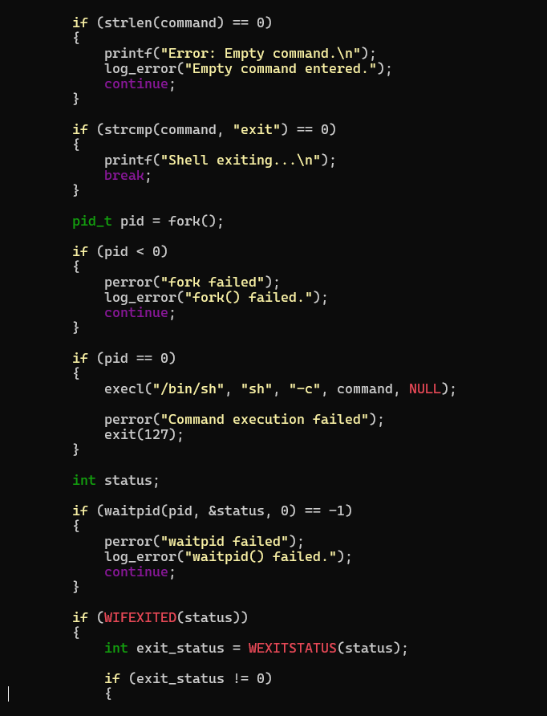
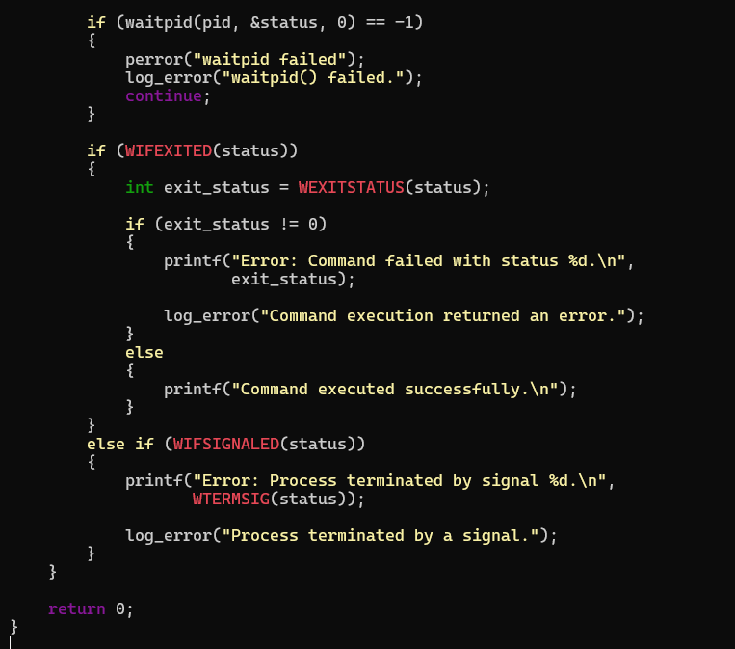
Output:
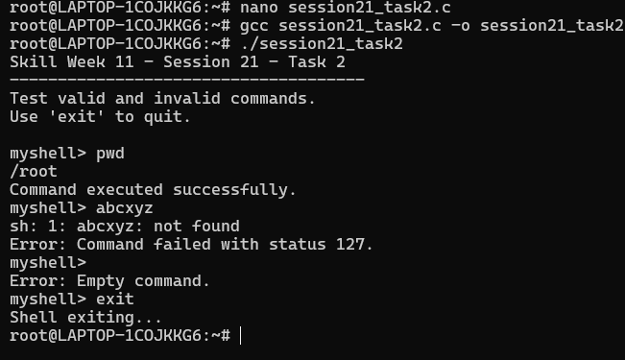
Observation: I learned how to detect runtime errors and invalid commands, generate meaningful error messages, and log failures. I also learned how a shell can recover from errors and continue execution without terminating.
Session -22
Task1: Develop a C program with dynamic memory allocation, analyze it using Valgrind, identify memory leaks, fix the memory errors, release resources, and verify proper cleanup.
Source code:
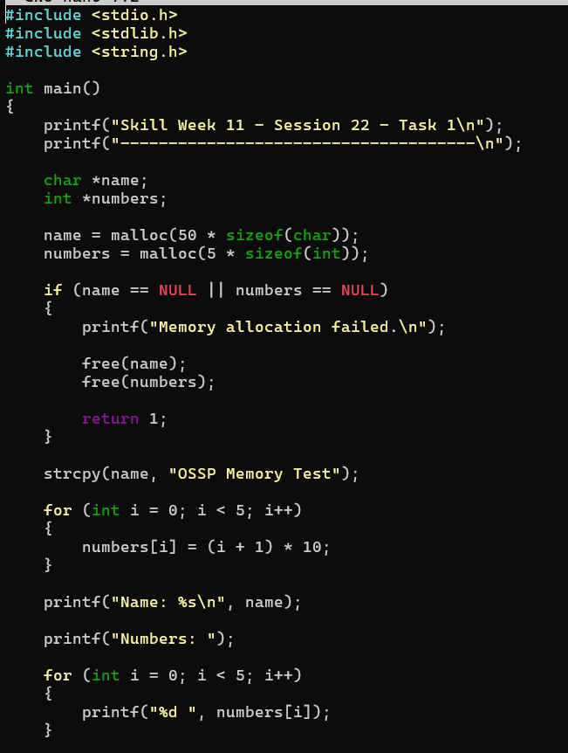
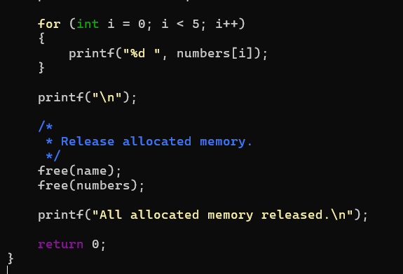
Output:
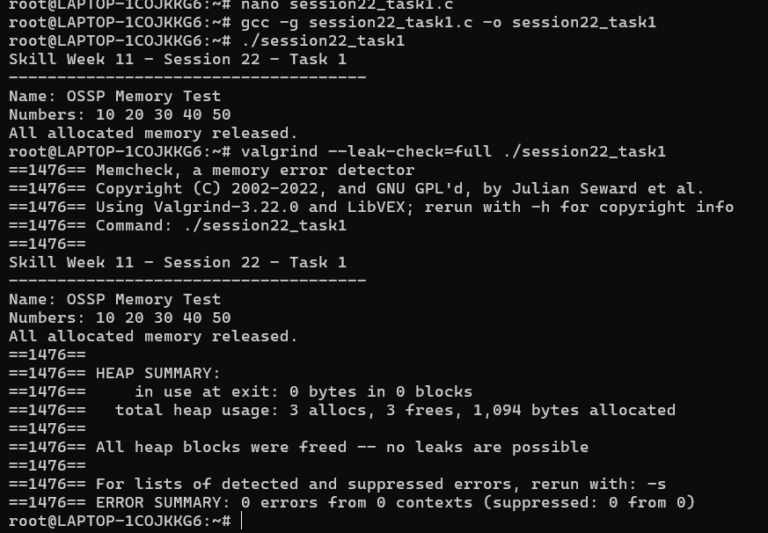
Observation: I learned how to use Valgrind to detect memory leaks and memory errors in a C program. I understood the importance of releasing dynamically allocated memory using free() and verifying proper memory cleanup using Valgrind.
Task2: Design test cases, create a test script, automate program execution, verify outputs, compare expected and actual results, and generate a test report.
Source code:
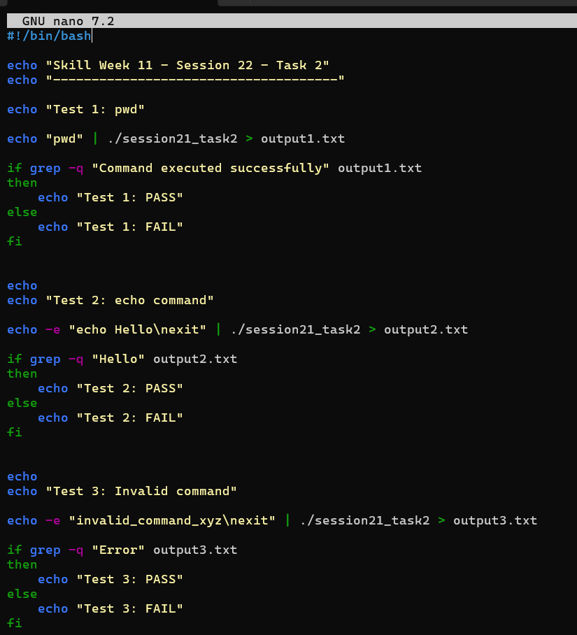
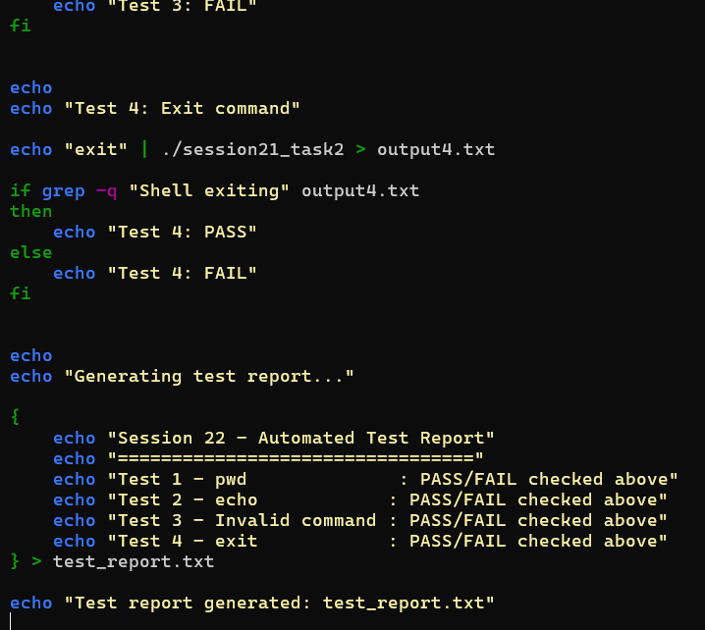
Output:
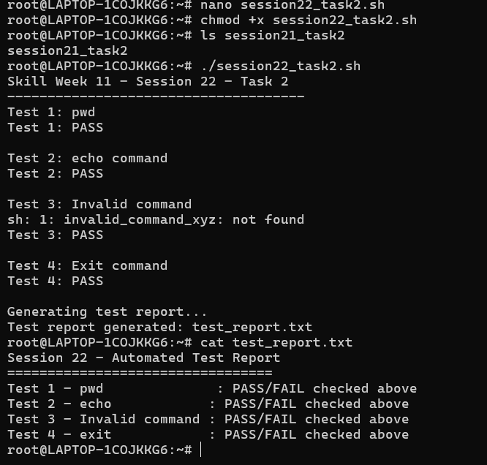
Observation: I learned how to design test cases and automate program testing using a shell script. I understood how to compare expected and actual outputs, identify PASS or FAIL results, and generate a test report.

